String Effects
Vibrato
A technique used most of the time in modern string playing to make the tone warmer and more expressive. The finger being used to play the note is rocked back and forth so that the pitch alters very slightly up and down. The player can vary the speed and width of the vibrato. Sometimes players are instructed to play senza vibrato (without vibrato) for a colder sound.

Legato/slurs
Playing notes smoothly; the effect
can be made even smoother by
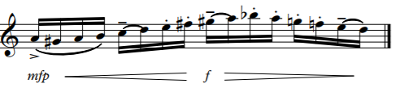
Special effects
Snap/Bartok Pizzicato
Plucking the string so hard that it hits the fingerboard (both instruments can
do this but cellos can do this more effectively as their strings are longer). Plucking the string so hard that it hits the fingerboard (both instruments can do this but cellos can do this more effectively as their strings are longer).
Glissando
Sliding the finger along the string to make the note ‘swoop’.
Col legno
Playing with the wooden stick of the bow instead of the hair.
Sul Tasto
Playing over the fingerboard for a very soft sound.
Sul Ponticel
‘slurring’ them in one bow. Strings
mfp f
Playing right on or very near the bridge for a rough/icy sound.

can also play very long sustained notes.
Mendelssohn Trio in D minor Andante con moto tranquillo
https://soundcloud.com/galos_trio/08-mendelssohn-piano-trio-in-d

Fibich Poème
https://soundcloud.com/galos_trio/04-fibich-poeme
Staccato
Short notes which strings can play either on (martelé) or off the string (spiccato/ bouncing bow).
Frank Bridge Hornpipe
https://soundcloud.com/galos_trio/06-bridge-hornpipe
Pizzicato
Plucking the strings with either hand but usually the bow hand. Arco (with bow) indicated at the end of a pizzicato.
pizz.
& >œ
sff

œ
œ
'
J
p
‰
œ
mf
œ
arco.
Œ
Carlos Gardel Tomo y Obligo (cello at the beginning)
https://soundcloud.com/galos_trio/09-gardel-arr-meredith-tomo-y
Double Stopping
Playing two notes at once. Chords of 3 or 4 notes can also be played but the notes need to be ‘spread’ across Trill
& œ˙™
œj
#Óœ
œ
pp
#œ
f
Rapidly changing notes a 2nd apart.
Tremolo
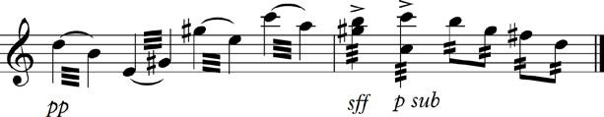
Bowing as fast as you can for a shivery effect, or rapidly changing between two notes further apart than a 2nd.
Mute
A device which clamps on to the bridge to make a softer sound.
Harmonics
Make a sound like whistling; there are two types:

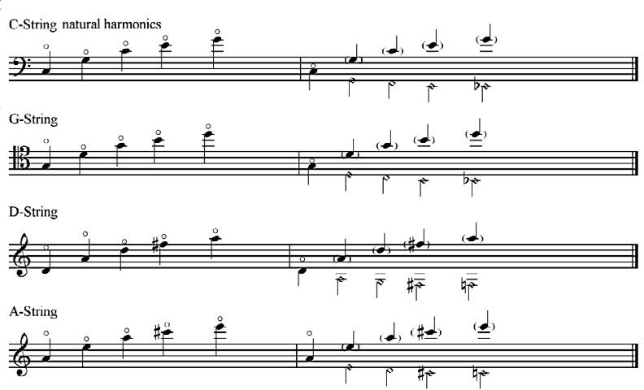
Natural harmonics are produced by lightly touching certain places on an open string. This technique only produces notes which are in the ‘harmonic series’, so not every pitch is possible. Sliding the finger between these notes can produce a magical
arpeggio effect. Write them as the note you want to hear with a little circle above it.
The diamond note- heads in the example show where the player touches the string to produce the natural harmonics on the open strings of a cello. The violin follows the same pattern.

False/artificial harmonics can be played by lightly touching the string a perfect 4th above any note, sounding two octaves higher. This is the most commonly used harmonic technique. It’s flexible enough that melodies can be played like this.

