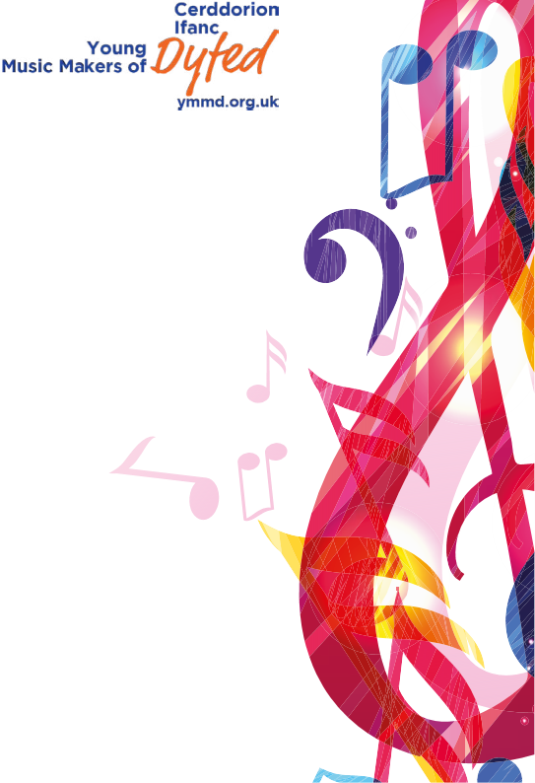

CYNGERDD CERDDORION IFANC
YOUNG MUSICIANS CONCERT

Nos Iau Medi 19^{ed} 2019
Thursday September 19th 2019
7.00 yh/pm

Eglwys y Santes Fair, Dinbych-y-pysgod
St Mary’s Church, Tenby

Mynediad: £8 (disgyblion dan 18 oed am ddim)
Tickets: £8. (students under 18 free)

