THE HERMES EXPERIMENT - Writing for soprano voice

Héloïse’s range:

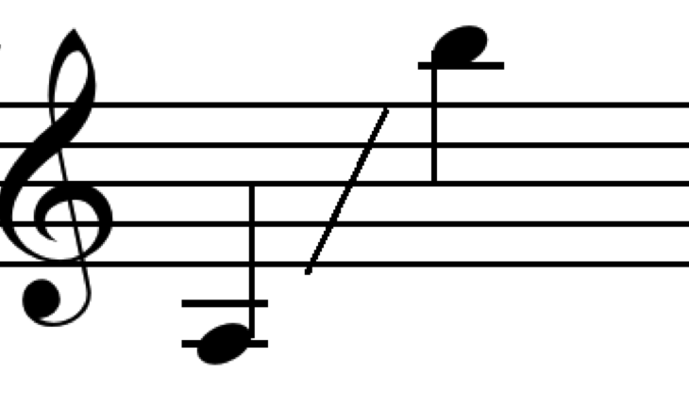

It’s important not to write outside this range.

Please also remember:

1. Only use the outer ranges very sparingly
2. Very high notes are best sung loudly
3. Don’t write lots of words, and especially not lots of important ones, at a very high range
4. In a vocal piece, it’s important to give the singer enough breaks i.e. don’t hesitate to write some instrumental only passages

Techniques you might want explore:

-quarter tones
-slow glissandi exploring all the possible notes in between each semitone
-broken up bits of words
-rolled « r » or lip trill « brrrr »
-humming

Pitchless sounds:
-unvoiced consonants (R / P / T / K / CH / F/ SS) used as percussive sounds
-whispering / speaking
-laughing / crying / gasping
-tongue clicks
-body percussion

