Double Bass

Double bass music is normally written in bass clef; each pitch sounds an octave below the written pitch. All musical examples below will sound an octave lower!
Double bass open strings:
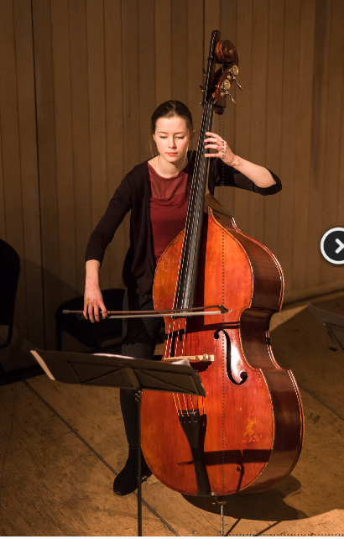

Double bass normal range:

Double bass extended range:

The lowest notes of the extended range are only possible if the player has a C extension, which the member of The Hermes Experiment will be using. The C extension allows the player to use notes that lie up to a major third below the open string (C, C#, D, D#). Use these notes sparingly, and also bear in mind that very fast music written on the extension is challenging!
The upper range of the double bass (from the top G of the normal range to the top D of the extended range) involves playing in thumb position.
Bow techniques:
legato – play notes smoothly. Use slurs to indicate that notes should be played in the same bow.

staccato – play notes separately and short.

Pizzicato – (pizz) the player plucks the strings rather than using the bow. Write arco (meaning ‘with bow’) when the player should resume using the bow.
Extended techniques
Snap pizz/Bartok pizz - a note is plucked so hard that it makes a slap noise as it hits the wood of the fingerboard of the instrument (see symbol notation below). This is a very loud effect on the double bass and should be used sparingly!

Glissando – slide the fingers of the left hand up or down the string to make a swooping, siren-like sound (write ‘gliss’ or use a straight line to connect noteheads). This can also be used in combination with natural harmonics (‘harmonic gliss.’ ).
Sul ponticello – play close the the wooden bridge of the instrument to produce a scratchy, icy sound (write ‘sul pont’, then ‘ord.’ to indicate a return to ordinary playing once the effect is finished)
Sul tasto – play over the fingerboard to produce a very soft sound (write ‘sul tasto’, then write ‘ord.’ to indicate a return to ordinary playing once the effect is finished)
Tremolo – bow as fast as you can to produce a shaking, trembling sound. Use multiple dashes through the note stems to indicate tremolo.
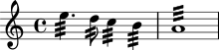
Con sordino – play using a mute placed on the bridge; this creates a slightly muffled sound. Write ‘con sord.’ to indicate this, then ‘senza sord.’ when the mute should be taken off.
Col legno – play notes percussively using the wooden side of the bow rather than the hair. Write ‘col legno’ to indicate this, then ‘ord.’ to return to ordinary playing.
Natural harmonics: these notes are played by lightly touching a string at specific harmonic nodes. This produces notes from the natural ‘harmonic series’ so only certain pitches will work on each string. The diagrams below show the natural harmonic pitches on each string and how to notate harmonics using a little circle above the notes:

Natural harmonics on G string

Natural harmonics on D string

Natural harmonics on A string
Natural harmonics on E string

