**Writing for the Clarinet**

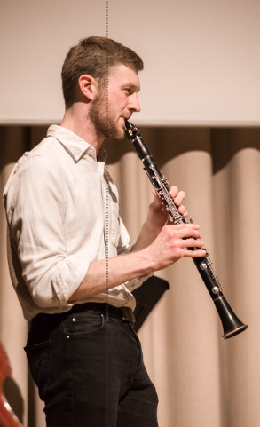

. When it comes to extended techniques, the clarinet is one of the most versatile wind instruments. The clarinet lends itself well to many extended techniques; below is a guide to those most commonly employed, with examples, prefaced by a page of general notes.

The clarinet has a written range from a low E anywhere up to a high C. The low register sounds dark and mellow, the middle register warm, rich, and melodic, and the high register shrill and penetrating. There are also some notes in between the low and middle registers that sound fairly woolly - avoid these if at all possible (there is sometimes a marked difference in timbre between these notes and those surrounding them).

.



Clarinettists are used to reading lots of different styles of articulation. Experiment to see how many different sounds you can get them to make! - We love long legato lines, but it's tricky to effectively slur down over large gaps. (Slurring up and jumping around staccato, however, isn't a problem.)

2.Extended techniques -(Those marked with an asterisk * have no standardised notation.)

- Air sounds* People often forget that wind players can simply breathe down their instrument without playing actual notes to create an effect. Bear in mind this is very quiet, and won't be heard above a general dynamic of ***mp***. You'll probably have to mark them ***ff***to be heard, even though the actual effect will be far from the conventional fortissimo! Don't forget to say whether you wish the player to breathe in or out.



. - Glissandi

While air sounds are subtle and delicate, glissandi are often far from this! The best clarinet glissandi are loud and fast, made by sliding ﬁngers off the keys. However, some glissandi can also work quietly, but be wary that these are difﬁcult to achieve



Multiphonics *

Multiphonics are a fantastic effect, but often unreliable. There are various books and websites detailing the most common ones found on the clarinet, but in general, it's more for a noise than speciﬁc chords. Mulitphonics are almost impossible to play quietly. The best thing to do in any instance is consult a performer, as often multiphonics sound different on every instrument



. Percussion

Another 'noteless' technique is that of hitting the keys with your ﬁngers. This is also a fairly quiet effect and so must be marked up accordingly.



. Quarter tones

Quarter tones, while not technically an 'extended technique', are deﬁnitely not used very often! There are no standard ﬁngerings for quarter tones on the clarinet, as it's desinged to play in semitones; however, any resourceful player will normally be able to ﬁnd a ﬁngering that works. Bear in mind that quarter tone ﬁnergings aren't usually possible between the lowest E and the G a minor third above that.



Singing and playing* This is a very rarely-used technique, and must be employed sparingly, as it is relatively tiring for the performer. Bear in mind that the player may sing in a different octave to the one written, depending on their voice type! Also err on the side of caution - not too much vocal virtuosity.



Timbral trill* Also referred to as 'bisbigliando' on the harp, the timbral trill is a 'trill' to a similar ﬁngering of the same note. Again, not all notes are possible, but it's an effect that's reliable at most volumes. The best notes to use are listed below (at written pitch), in addition to the most common notation used:

