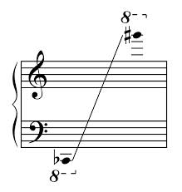
HARP

Range of the harp

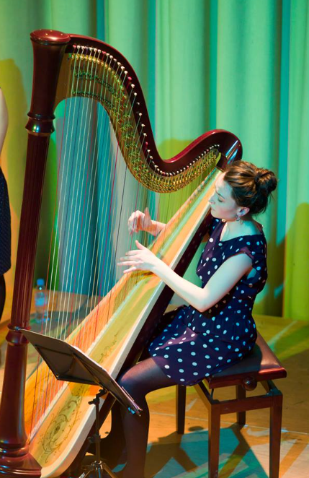

©Bart Lenoir
Pedal system
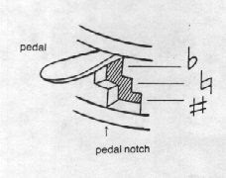
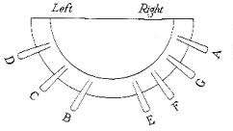
Seven pedals, one for each note of the scale, and each pedal has three positions, one each for flat, natural and sharp – this is how the harp achieves different keys and accidentals. So for example, a chromatic scale is very impractical on the harp! Try to avoid the harpist having to move pedals on the same side of the harp at the same time.

Layout
Harp music looks exactly like piano music, but avoid the following:
- The hands playing at opposite ends of the harp
- Too much jumping around between different octaves
- Five note chords or patterns (harpists only use FOUR fingers to play, not five like the piano)
- Playing very low with both hands

Ideas
- Harmonics – they sound an octave higher than written and sound magical on the harp
- Bisbigliando – this is notated like a tremolo and involves the harpist repeatedly playing the same strings - it gives a shimmering effect
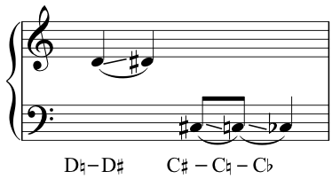
- Glissando – sliding the finger along the strings. You can also ask the harpist to use their nails or a plectrum to glissando which create contrasting sounds
- Percussive effects – the harpist can drum on the body of the harp using different parts of their hand to get different sounds
- Pedal slides – the harpist moves the pedal while the string is still resonating creating a slide effect
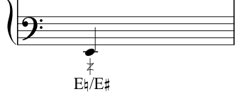
- Pedal buzz – the harpist holds the pedal between two notches so that the string buzzes against the mechanism (only works on bass strings)

