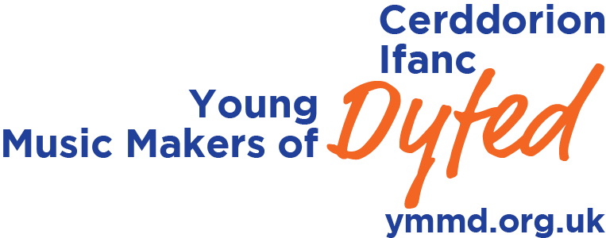

Young Musician of Dyfed
Young Musician of Dyfed is a process and competition for instrumental players under the age of 19yrs. It is open to young people living or in full time education in Carmarthenshire, Ceredigion and Pembrokeshire.

We believe that what we offer is unique in the UK. We offer all our applicants an individual masterclass led by a pre-eminent musician and an equally well-established pianist who is available to play for those instrumentalists requiring accompaniment. These masterclasses replace the traditional preliminary round and once they have all taken place, our masterclass leaders select five players to go through to the Young Musician of Dyfed final.

Our Masterclasses
Our masterclasses are designed to develop your performance skills and to deepen your understanding and interpretation of the music. They are not about offering you technical advice as we feel this is best left with your teachers. It’s a great way to learn, to gain inspiration for your own personal development and to take away a wealth of knowledge that you can apply to all aspects of your own playing.

This year’s masterclasses will take place at Neuadd y Dderwen, Rhosygilwen, nr Cilgerran on Saturday 27 and Sunday 28 October 2018. They will be led by composer, pianist and conductor, Andrew Wilson-Dickson and Kevin Price, Head of Brass and Percussion at the Royal Welsh College of Music and Drama. Both Andrew and Kevin have worked with young people over many years and are fantastic communicators.

The masterclasses are not held behind closed doors so you may be performing in front of a small audience but in a relaxed and informal atmosphere. Above all, we want you to enjoy the experience and help increase your confidence when playing – be it at a concert, a school assembly or in an exam.

Here is some feedback from previous masterclass participants:

I really liked the masterclass format - it was much less intimidating and I think it made the competition more accessible because even if you knew that you didn't really have a chance of going through to the final it was still an amazing experience and you got something worthwhile out of it.

It is always valuable and a privilege to have the coaching of a professional musician – especially if it’s absolutely free of charge! I feel this format also allows the adjudication to reflect upon the competitor’s general musicianship and ability to respond to suggestions and criticism on the spot – an essential quality of a musician, I’m sure you’ll agree – and one which often cannot be judged in the more traditional format of music competitions.

To take part in our masterclasses you should:
- Be under 19yrs of age on 1st September 2019
- Permanently resident or in full time education in Carmarthenshire, Ceredigion or Pembrokeshire
- Grade 5/6 equivalent standard or above

Please prepare a single piece of music no longer than five minutes in length. This may be a stand-alone piece or a movement/part of a movement from a longer work. Each masterclass will last between 20 – 25 mins, depending on the number of entrants.

To take part, simply fill in the application form and either email it to morris.c@ntlbusiness.com or post it to the address provided. The deadline is Wednesday 17 October 2018.

Piano Accompaniment
Piano accompaniment will be provided by Andrew Wilson-Dickson on the day of the masterclass but if you would prefer to bring your own accompanist then this option is available to you.

Costs
The masterclass is free of charge. However you should be aware that places are limited and available on a first come, first serve basis.

Following the Masterclass
Following all the masterclasses, Andrew and Kevin will select five players to go through to compete for the title of Young Musician of Dyfed. This process is solely in their hands and their decision is final.

Young Musician of Dyfed Final
The final will be a public concert held at Neuadd y Dderwen, Rhosygilwen over the weekend of 6/7 April 2019 - date and time to be confirmed.

Each player will need to prepare a programme no longer than 15 mins in duration. Andrew and Kevin will be joined by a further professional and together they will make the decision as to who to award the title Young Musician of Dyfed.

Should you have any questions, please don’t hesitate to contact Emyr Wynne Jones by email – llysynant@gmail.com

