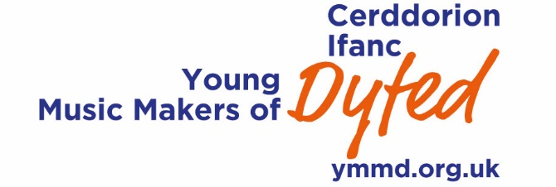

Young Ensembles of Dyfed
Young Ensembles of Dyfed is an exciting initiative open to young players and singers who perform together as members of an ensemble.

Young Music Makers is offering young ensembles the opportunity of benefitting from an individual masterclasse in January 2019. The masterclasses will take place in a school or schools based in Carmarthenshire, Ceredigion and Pembrokeshire and our aim is to offer the members of the group advice and support on:
• listening, watching and interacting
• musical interpretation
• achieving the right balance
• phrasing, articulation and dynamics
• tuning and intonation
• developing good stagecraft and performance techniques

The masterclasses will be led by members of The Hermes Experiment (www.thehermesexperiment.com). They have worked across a range of musical genres from opera to pop and with a wide range of ensembles, bands and orchestras.

Your ensemble should prepare a piece of music lasting no longer than 5 minutes in length.
If performing from a written score, a copy of this should be made available on the day of the masterclass.

Definition of an Ensemble
We define an ensemble as a group two* or more instrumentalists/singers who perform without a conductor and with each player having an independent line.
*a soloist with accompaniment is not considered as an ensemble

Who can take part?
The masterclasses are open to young ensembles whose members are:
• under 19yrs on 1 September 2019
• living or attending full time education in Carmarthenshire, Ceredigion or Pembrokeshire.

The ensemble can select a musical genre of their choice e.g. classical, jazz, folk, blues, rock, pop, world.

To apply for a masterclass, simply fill in the application form and email it to Emyr Wynne Jones – llysynant@gmail.com, or by post to the address given. If you have any queries, please contact Emyr.
The deadlines for applications is Friday 14 December 2018.

